**QUIZ RESULTS**

**MODULE6: MODELING UNBALANCED CLASSES**

|  |  |  |  |  |
| --- | --- | --- | --- | --- |
| **No.** | **Quiz title** | **Completion Status** | **Score** | **Coursera link** |
| 1 | Module6_1_Model interpretability | Completed | 100% | [Quiz 1](https://www.coursera.org/learn/supervised-machine-learning-classification/assignment-submission/QYFyo/practice-model-interpretability/view-feedback) |
| 2 | Module6_2_Modeling Unbalanced Classes | Completed | 100% | [Quiz 2](https://www.coursera.org/learn/supervised-machine-learning-classification/assignment-submission/ok5IY/modeling-unbalanced-classes/view-feedback) |
| 3 | Module6_3_Graded Quiz | Completed | 100% | [Quiz 3](https://www.coursera.org/learn/supervised-machine-learning-classification/assignment-submission/UdNql/module-6-graded-quiz/view-feedback) |

# Module6_ Model Interpretability

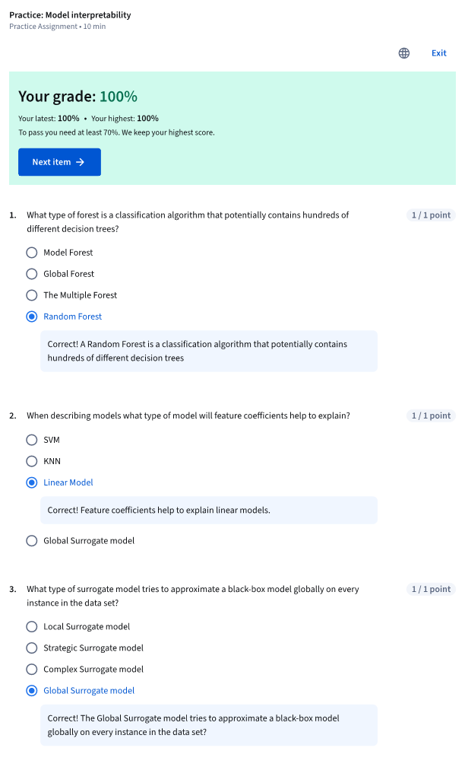

# Module6 _ Modeling Unbalanced Classes

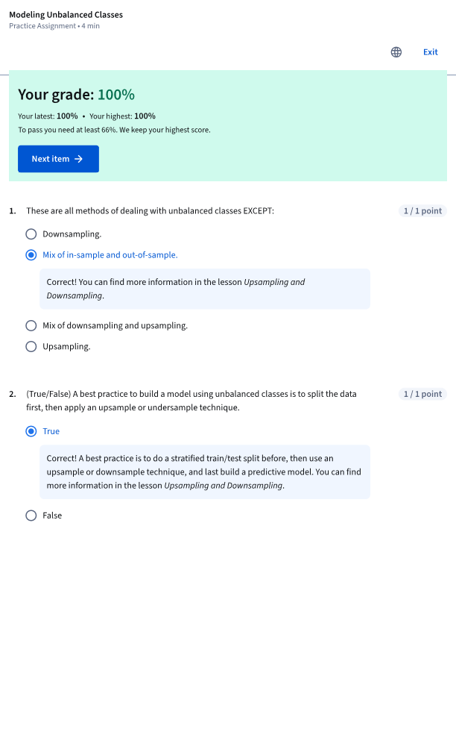

# Module6 _Graded Quiz

